Project Planning Phase
Project Planning Template (Product Backlog, Sprint Planning, Stories, Story points)

Date | 2 Feb 2026
Team ID | LTVIP2026TMIDS24922
Project Name | Toycraft Tales: Tableau's Vision into Toy Manufacturer Data
Marks | 8 Marks

Product Backlog, Sprint Schedule, and Estimation (4 Marks)
print | Functional  Requirement (Epic) | User Story Number | User Story / Task | Story Points | Priority | Team Members
Sprint- 1 | Dashboard widgets | USN-1 | As a user, I want to view Product sales by category on a dashboard to identify bestaligns. | 3 | High | Pujitha
Sprint- 1 | Dashboard widgets | USN-2 | As a user, I want to compare Product sales across different regions on a dashboard for geographic insights. | 2 | High | Rohith
Sprint- 1 | Filter Options | USN-4 | As a user, I want to filter products to show only the top-rated items based on users. | 3 | Medium | Charan
Sprint- 2 | Filter Options | USN-5 | As a user, I want to filter products by price range on the dashboard to find item within my budget. | 3 | High | Pujitha
Sprint- 2 | Filter Options | USN-6 | As a user, I want to filter products by availability to ensure items are in stock when I view them. | 2 | Medium | Charan
Sprint- 2 | Filter Options | USN-7 | As a user, I want to filter products by category to narrow down choices for easier browsing. | 1 | Low | Rohith
Sprint- 3 | Map Integration | USN-8 | As a user, I want to view store locations on a map for better navigation. | 4 | Low | Pujitha

Sprint- 3 | Dashboard Expert | USN-9 | As a user, I want to export dashboard data to a spreadsheet for analysis and reporting. | 4 | High | Charan

Project Tracker, Velocity & Burndown Chart: (4 Marks)

Sprint | Total Story Points | Duration | Sprint Start Date | Sprint End Date (Planned) | Story Points Completed (as on Planned End Date) | Sprint Release Date (Actual)
Sprint- 1 | 11 | 3 days | 29 Jan 2026 | 31 Jan 2026 | 11 | 31 Jan 2026
Sprint- 2 | 10 | 3 days | 01 Feb 2026 | 03 Feb 2026 | 10 | 03 Feb 2026
Sprint- 3 | 07 | 3 days | 04 Feb 2026 | 06 Feb 2026 | 07 | 06 Feb 2026
Sprint- 4 | 07 | 3 days | 07 Feb 2026 | 09 Feb 2026 | 07 | 09 Feb 2026

Velocity:
Imagine we have a 10-day sprint duration, and the velocity of the team is 20 (points per sprint). Let’s calculate the team’s average velocity (AV) per iteration unit (story points per day)

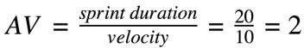

Burndown Chart:

https://www.visual-paradigm.com/scrum/scrum-burndown-chart/

https://www.atlassian.com/agile/tutorials/burndown-charts

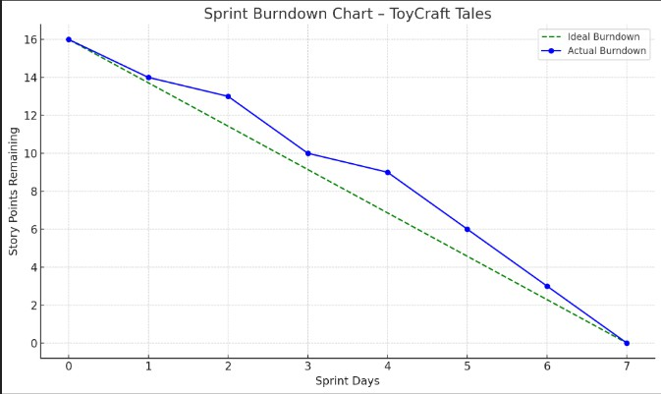

Reference:

https://www.atlassian.com/agile/project-management
https://www.atlassian.com/agile/tutorials/how-to-do-scrum-with-jira-software https://www.atlassian.com/agile/tutorials/epics
https://www.atlassian.com/agile/tutorials/sprints https://www.atlassian.com/agile/project-management/estimation https://www.atlassian.com/agile/tutorials/burndown-charts

